 

Project Title: Lease Management

College Name: SREE SAKTHI ENGINEERING COLLEGE:7136

Department of Computer Science and Engineering

## Team Leader:

Name: Ambrish M Reg No: 713621104007

## Team Members:

Name: Abinesh S Reg No: 713621104004

Name: Venkatesan P Reg No: 713621104045

Name: Abilash S Reg No: 713621104302

Registered Email Id:ambrish2706@gmail.com

 

# Project Name: Lease Management

### Project overview:

This project aims to develop a Lease Management System in partnership with Salesforce.com, creating a specialized application for property management. The LMS application includes all necessary functionalities to manage various operations within the real estate sector, in accordance with recognized best practices. Delivered as a Software as a Service (SaaS), it is accessible online from any device. The technological infrastructure is supported by Salesforce.com (www.salesforce.com), which guarantees secure data storage and the implementation of essential security protocols. The purpose of this study was to design and implement a cloud-based Lease Management System that offers both detailed and summarized insights into key areas, assisting LMS administrators in their planning and decision-making processes. The system is available at any time and from any location, as data is stored remotely and can be accessed via the Internet. This initiative prioritizes user-friendliness, usability, performance, and security, showcasing its robustness. As a result, other property owners may be encouraged to adopt this system for improved information management, enhanced decision-making, and the cultivation of strong client relationships, as the LMS streamlines the management of real estate operations.

### Objective:

The main objective of a leave management system is to help businesses manage employee absences in a fair and accurate way. This can be achieved by:

**Business Target:**

Asset leasing is a popular option for businesses, regardless of their size or industry. This practice delivers a range of benefits, such as enhanced purchasing power, lower maintenance costs (assuming the lessee is not liable for maintenance), and more efficient cash flow management.

 

**Particular goal:**

Asset leasing is a popular option for businesses, regardless of their size or industry. This practice delivers a range of benefits, such as enhanced purchasing power, lower maintenance costs (assuming the lessee is not liable for maintenance), and more efficient cash flow management.

**Enhancing the efficiency of the leave application process.**

#### A leave management system operates as an intermediary between employees and employers, optimizing the leave application and approval procedures for greater effectiveness.

#### Facilitating clarity and management.

Employees should establish a simple system for submitting leave requests, obtaining their leave information, and overseeing the progress of their leave applications.

**Streamlining processes by removing paper-based tasks**

#### It is advisable for employees to implement a straightforward method for submitting leave requests, retrieving their leave information, and monitoring the progress of their leave applications.

#### Fulfilling legal requirements.

#### Employees should consider utilizing an easy-to-follow approach for submitting leave requests, checking their leave information, and monitoring the advancement of their leave applications

 

**Salesforce Key Features and Concepts Utilized**

**Organization:**

Formulating a detailed sales strategy and assigning specific tasks to team members.

**Sales Tactics:**

Developing and implementing clear and actionable sales strategies.

**Customer Engagement:**

Fostering meaningful relationships with essential clients.

**Sales Data Analysis:**

Reviewing past campaign metrics to create more effective and efficient sales initiatives.

**Training:**

Supporting sales representatives in enhancing their performance and reaching their highest potential.

**Forecasting:**

Preparing for future demands to ensure proper inventory management, staffing, and compensation planning.

 

# Detailed steps to solution design

### Step 1: Creating Developer Account and Activation

To create a developer organization within Salesforce, start by activating your account.

Click on the "Verify Account" link, then set a password and provide an answer to a security question.

After clicking "Change Password," you will be redirected to the Salesforce setup page.

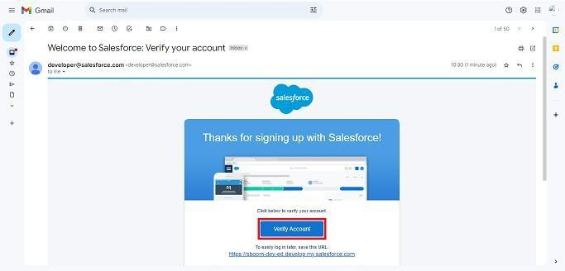

 

### Step 2: Create of objects

Create Property Object, tenant object, lease object and payment object.

From the setup page >> Click on Object Manager >>Click on Create >> Click on Custom Object

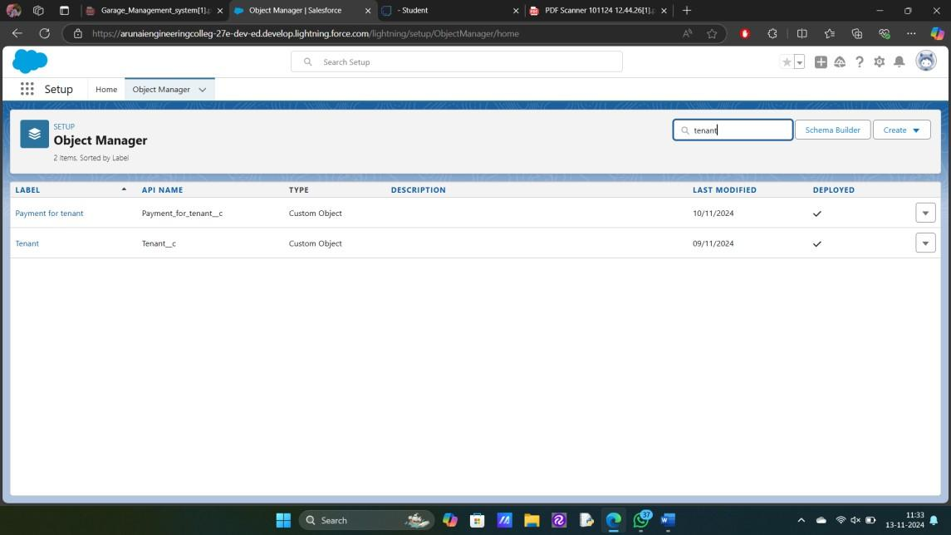

Enter the label name for the appropriate object. Then enter the Plural label name.

Enter Record Name Label and Format Record Name and Data Type.

### Step 3: Creating a Custom Tab

A tab is like a user interface that is used to build records for objects and to view the records in the objects.

 

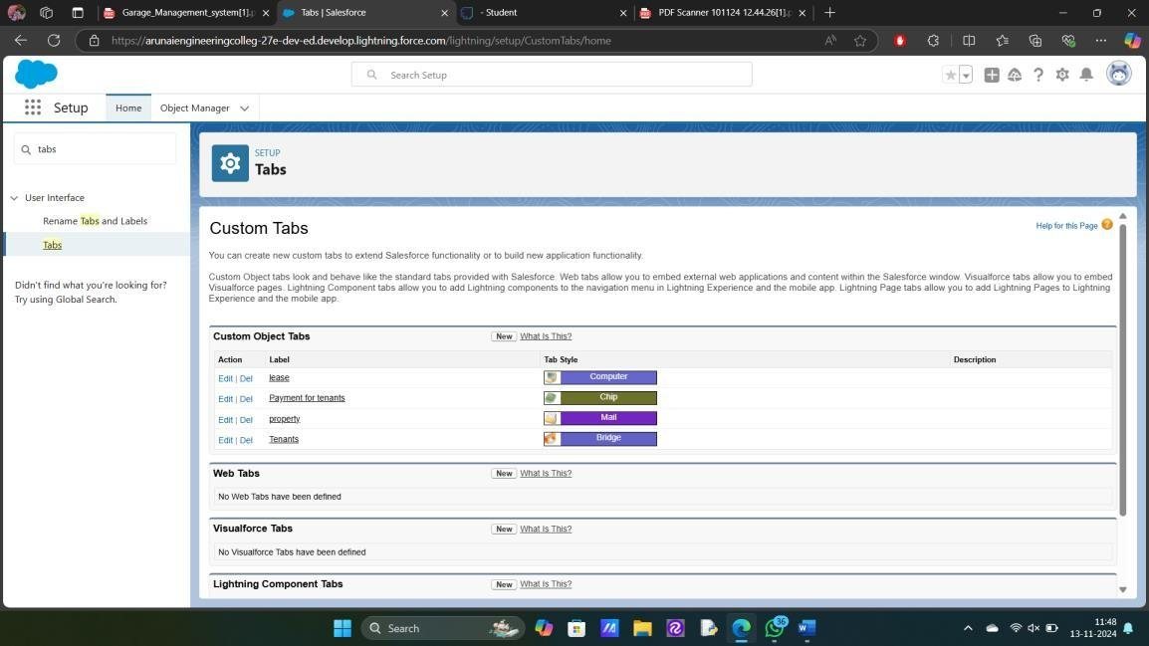

### Step 4: Create a Lightning App

An app is a collection of items that work together to serve a particular function.

### To create a Tab:( Property)

* Goto set up page. Search tabs on quick find bar click new under custom tab.
* The first step is to select object property and tab style.
* Make sure that the Append tab to users' existing personal customizations is checked. Click save

 

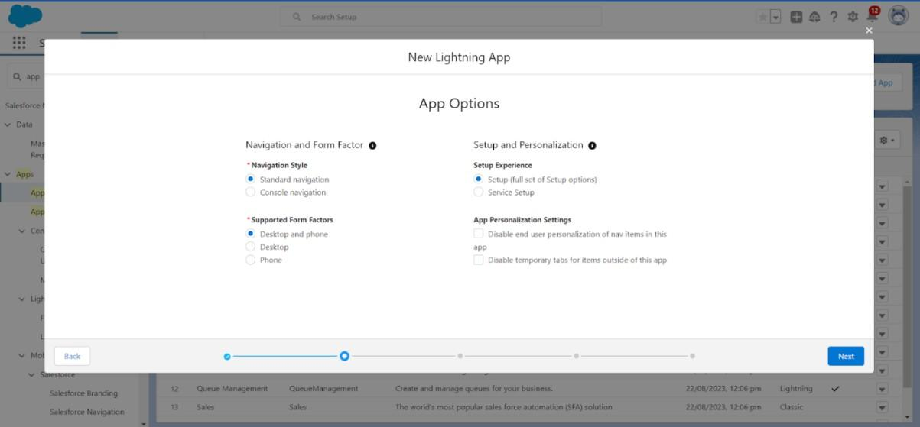

Create a lightning app with an App Name of “Lease Management”

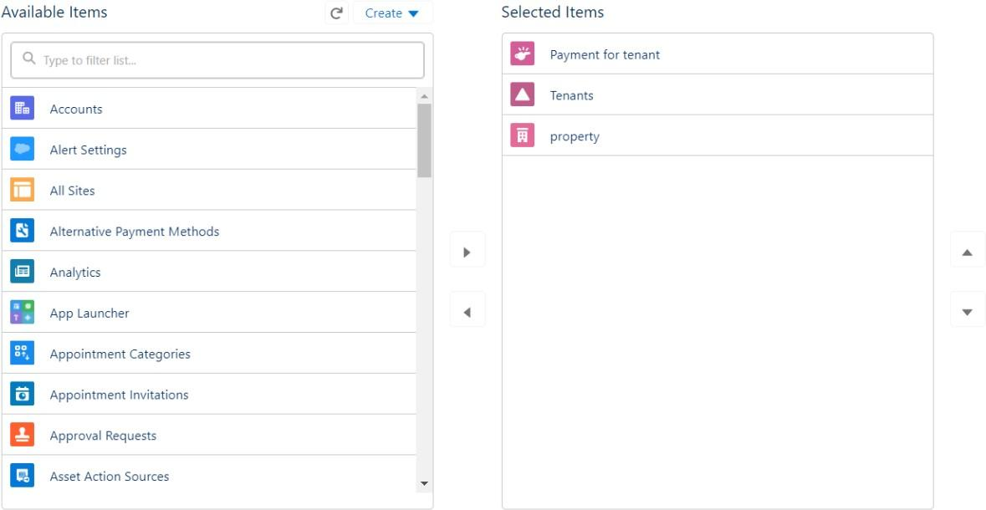

### Step 5: Field Creation

Creation of fields for the property object, Tenant object, Lease object, Payment for tenant object, Lookup object.

 

Go to setup then click on Object Manager to type object name(Tenant) in search bar and click on the object.

* Field Label : Email
* Field Name : gets auto generated
* Click on required check box
* Click on Next >> Next >> Save and new.
* Field Label : start date
* Field Name : gets auto generated
* Click on Next >> Next >> Save and new.

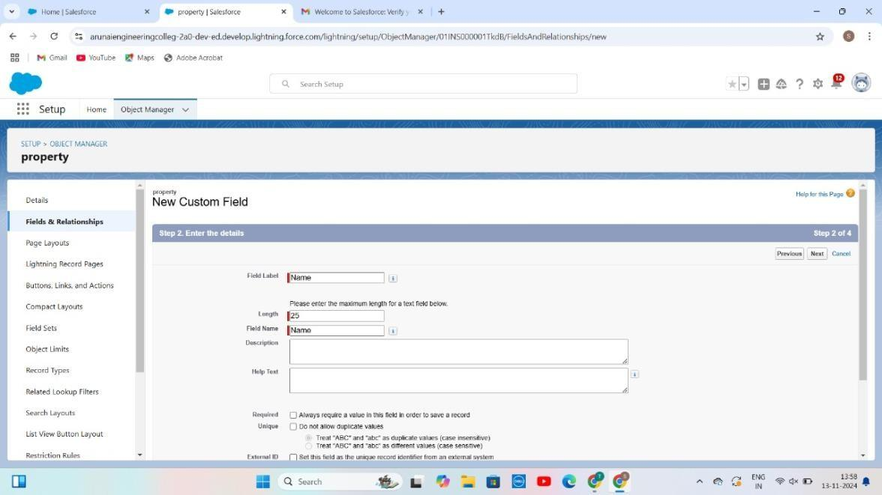

 

### Step 6: Validation rules

To create a validation rule to an Lease Object.

Go to the setup page click on object manager from drop down click edit for Lease object**.**

Click on the validation rule.click new Rule name= lease_end_date

* + Insert the Error Condition Formula as : End_date c > start_date c

Enter the Error Message as “Your End date must be greater than start date”, select the Error location as Field and select the field as “start date”, and click Save.

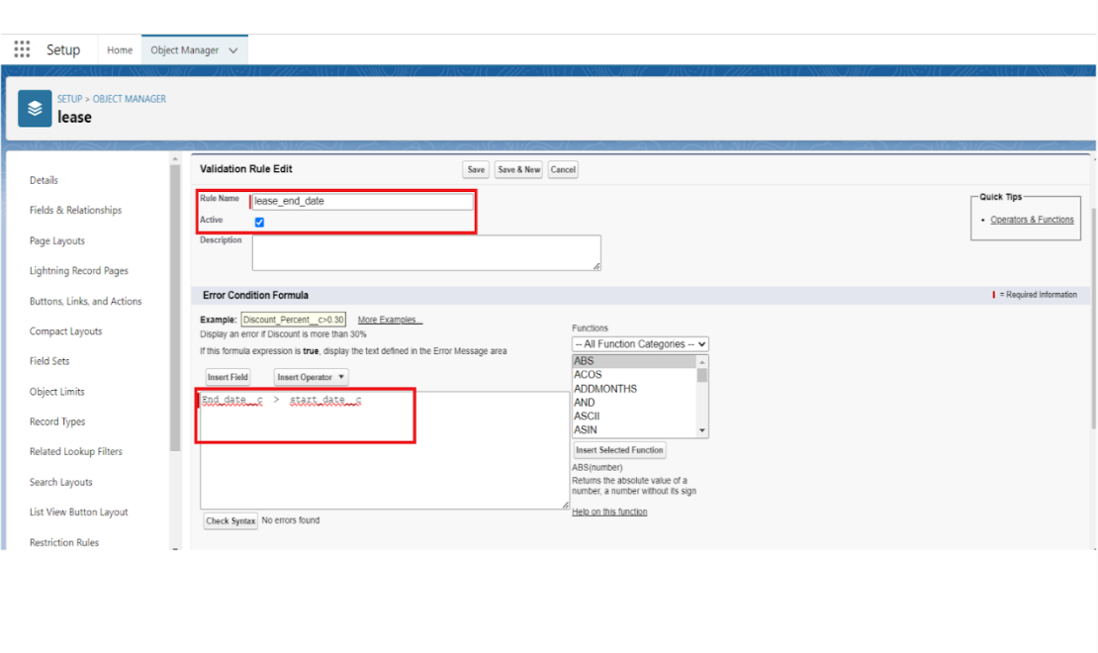

 

**Step 7: Email templates**

### Create Email Template For Tenant Leaving

* + Go to setup in quick find box enter email template, click on classic Email template.
  + Then click on new email template choose text
  + Email template name: tenant leaving
  + Template unique name: Auto populated
  + Subject: request for approve the leave
  + Email body:

Dear {!Tenant c.CreatedBy}, Please approve my leave.

* + Save.

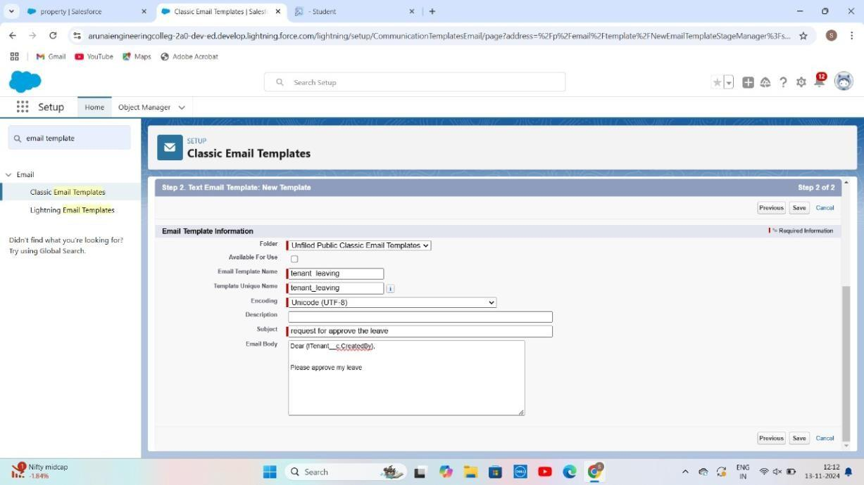

 

### Create Email Template For Leave Approved

* + Go to setup in quick find box enter email template >> click on classic Email Template.
  + Click on >> New Email Template===>Choose text
  + Email Template Name=Leave approved
  + Template Unique Name : Auto populated
  + Subject =Leave approved
  + Email body :
  + dear{!Tenant c.Name},

I hope this message finds you well. I am writing to inform you that I have received your email confirming the approval of my leave request. I would like to express my gratitude for considering and approving my time off.

Your leave is approved. You can leave now.

* + Save

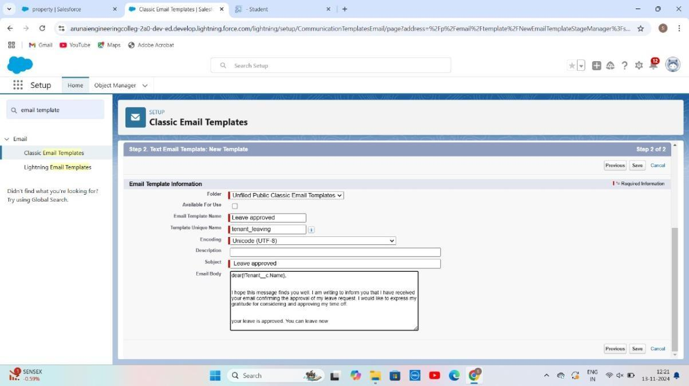

 

### Create Email Template For rejection for leave

* + Go to setup in quick find box enter email template >> click on classic Email Template.
  + Click on >>New Email Template===>Choose text
  + Email Template Name=Leave rejected
  + Subject : ” Leave rejected”
  + Email body :
  + Dear {!Tenant c.Name},
  + I hope this email finds you well. Your contract has not ended. So we can't approve your leave
  + your leave has rejected
  + Saved

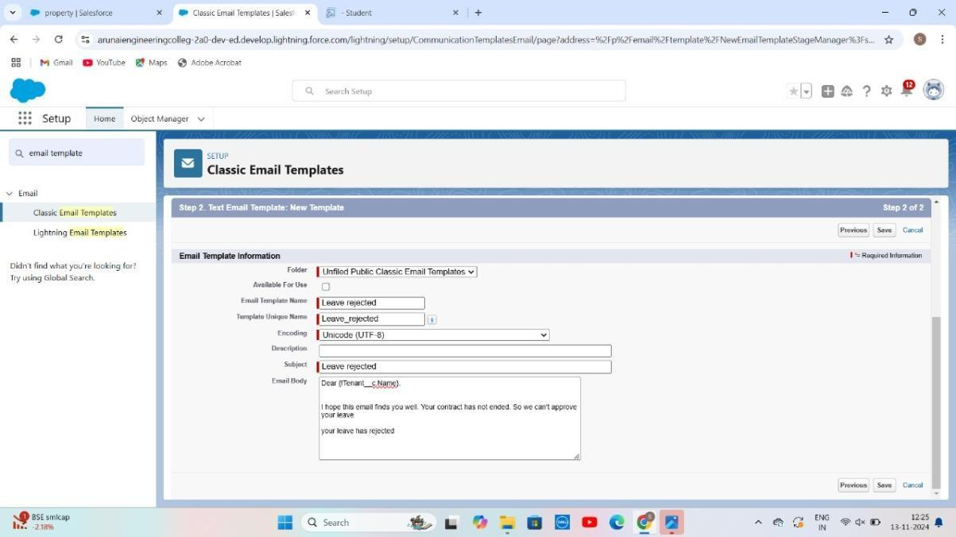

 

## Step 8:Approval Process

### What Is Approval Process In Salesforce?

The Approval Process is an automated process that an org uses to approve records in Salesforce. For example, When In the organization, someone is not able to decide a particular thing then he can ask someone else for

approval. So, for such frequent cases or situations, one can define the approval process. So, Users can take benefit of such an approval process whenever

needed.

There are 4 actions,

1. Initial Submission Actions
2. Final Approval Actions
3. Final Rejection Actions
4. Recall Actions.

An approval process consists of finalizing the basic properties of the approval process (as shown in the below image), approval steps, and actions to be

executed.

### Create Approval Process For check for vacant.

* + Go to setup >> Approval Processes in quick find bar>>click on it.
  + Manage Approval Process For >> “Tenant” from the drop down.
  + Click on “Create New Approval Process” >> Use standard setup wizard
  + Process Name “check for vacant” >> Click Next.
  + Field “Tenant:status” >> Operator : Not equals , Value >> Click on the lookup filter icon and select “Leaving”.
  + 6.Click insert field,then click Next.

 

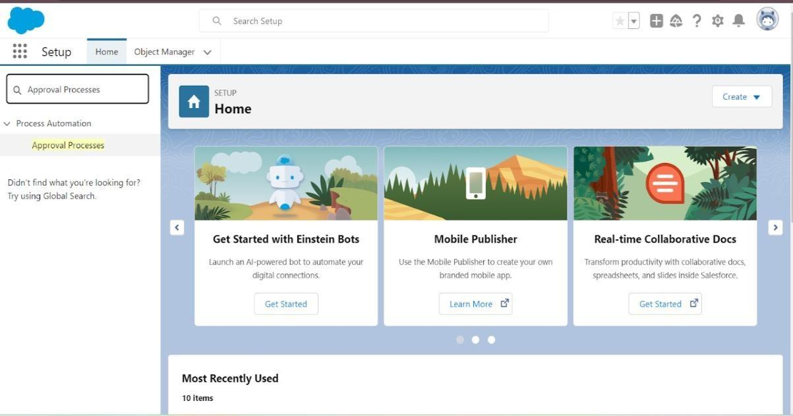

* Next Automated Approver determined by “None” from the drop down.
* Select the “Administrators ONLY can edit records during the approval process”. Then Next.

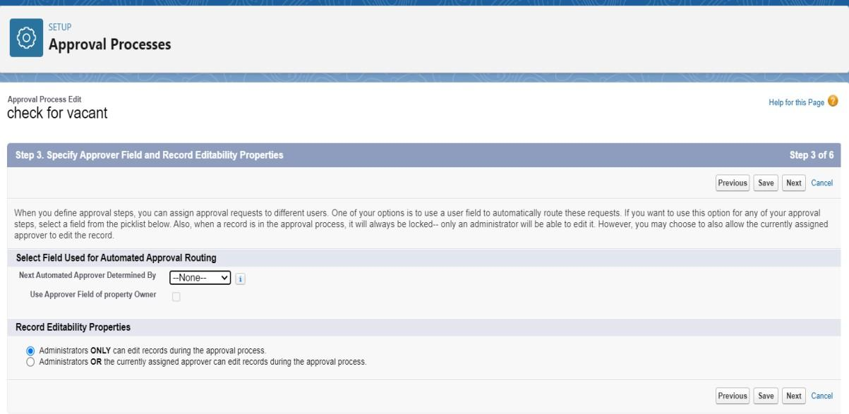

 

* Click on next leave the email template click on next
* Submitter type Search>>Owner, Allowed Submitters>>Property Owner. Then Next.
* Then click on Save.

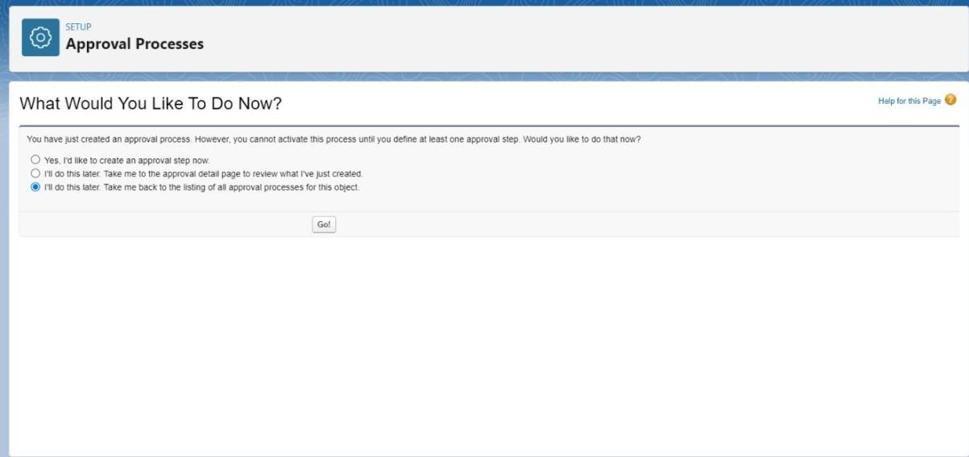

* Click on “i’ll do this later. Take me back to the listing of all approval process for this object”
* Click go.

### Initial Submission Action:

* + Under initial submission action click on add new and then select email alert.
  + Description: “please approve my leave”.
  + Unique name: auto populated.
  + Email template: tenant leaving.
  + Recipient type: Email field.

 

## Step 8: Flows

In Salesforce, a flow is a tool that automates complex business processes. Simply put, it collects data and then does something with that data. Flow Builder is the declarative interface used to build individual flows.

**Create Flow for monthly payment**

1. Go to setup then type Flow in quick find box Click on the Flow and Select the New Flow.
2. Select the record Triggered flow. Click on create.

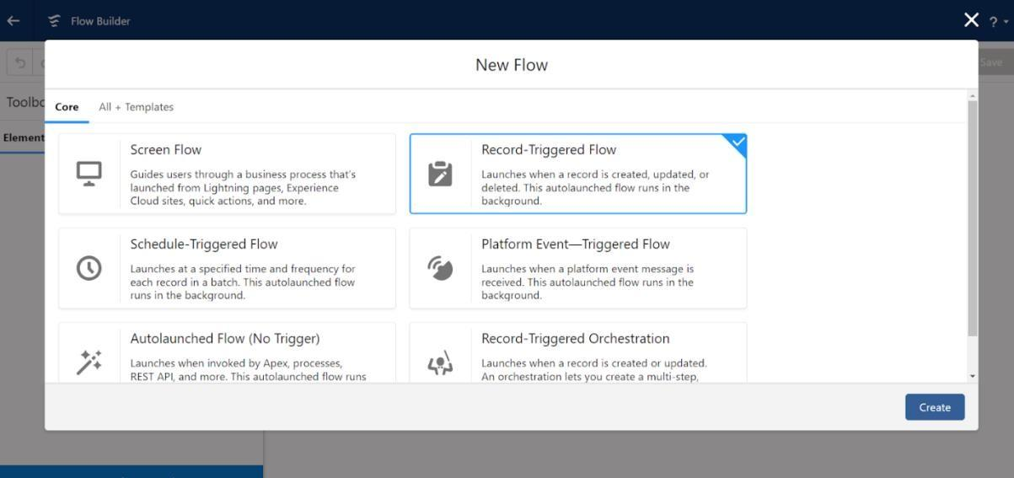

Click on: Every time a record is updated and meets the

condition requirements Click on: Actions and related records is done

 

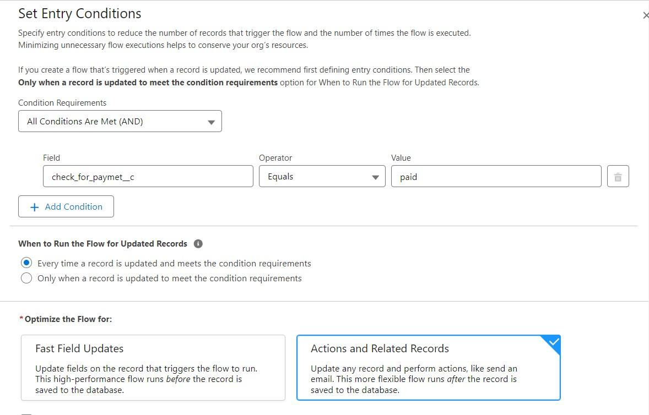

## Test and validation:

Testing and validation in lease management can involve a variety of activities, including:

**Lease validation services:**

id property management organizations in ensuring that their lease agreements are legally sound and enforceable. These services can facilitate the identification of issues and the verification of the lease's terms and conditions.

### Test planning and execution:

This task includes the implementation and supervision of validation tests based on a specified test plan and design. Additionally, it involves confirming and validating the results of these tests, along with the documentation and reporting of any issues or defects that arise.

 

### Test objectives and criteria:

Before beginning the testing and validation process, it is important to define these aspects clearly and explicitly. They should be consistent with the project's aims, scope, specifications, and the requirements and expectations of stakeholders and user

### Validation testing:

This procedure is utilized to ascertain that the end product meets the expectations and requirements set forth by customers and stakeholders. It usually takes place once the product is completely developed, concentrating on validating its performance in real-world applications.

# Conclusion:

# For individuals struggling to secure funds through conventional debt financing, lease financing presents a strategic solution. It allows property owners to lease their assets to businesses, promoting a constructive relationship between lessors and lessees. Our CRM-optimized lease management system enhances this experience by enabling users to find the best locations for residential and commercial use. This initiative is valuable for both homeowners and business owners alike.

# 